LAB#9
INTRODUCTION TO NOSQL: MONGODB

Objective:
- To understand NoSQl.
- To get familiar with MongoDB and its terminologies
- To apply CRUD operations in MongoDB.

LAB TASKS:
- Create a database with the name bookstore and create multiple collections. For instance: Books, authors etc.
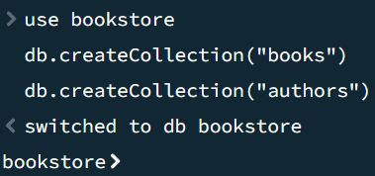
- Insert few records in both collections with different fields.
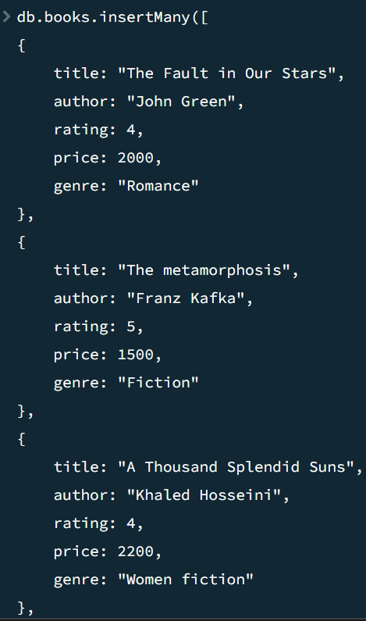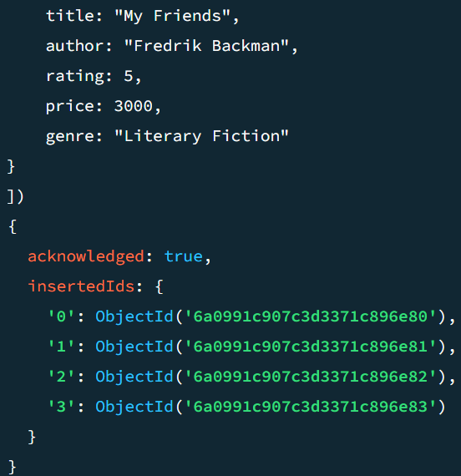
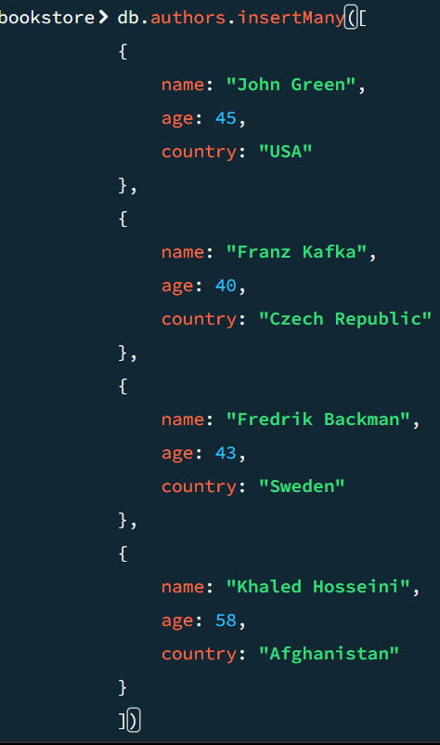
- Find the books with the rating 5 from the books collection. Find the author details whose name is John Green.
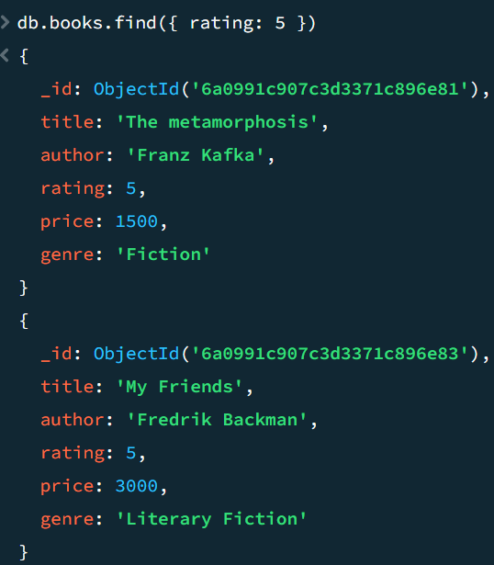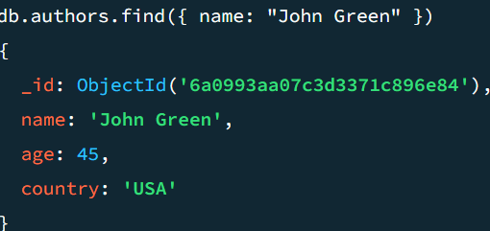
- Update the names of the books with the author name John Green.
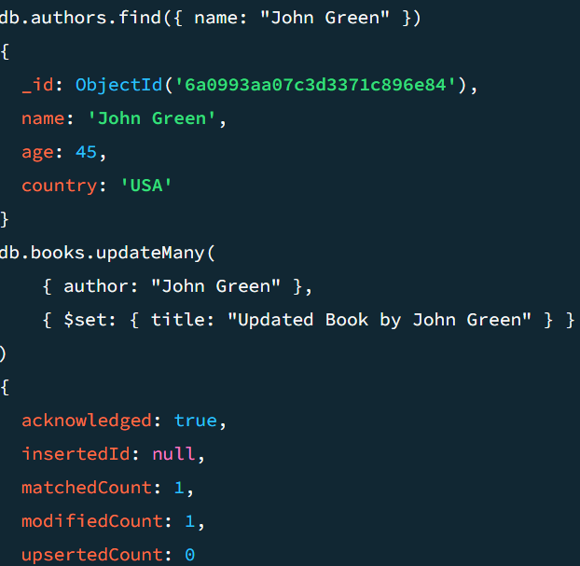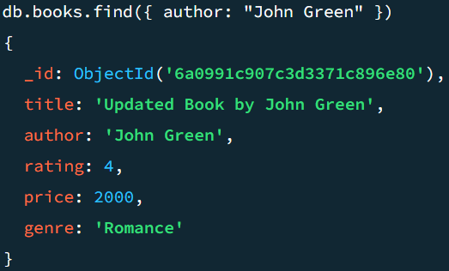
- Explore and embed the method sort(), distinct(), count().
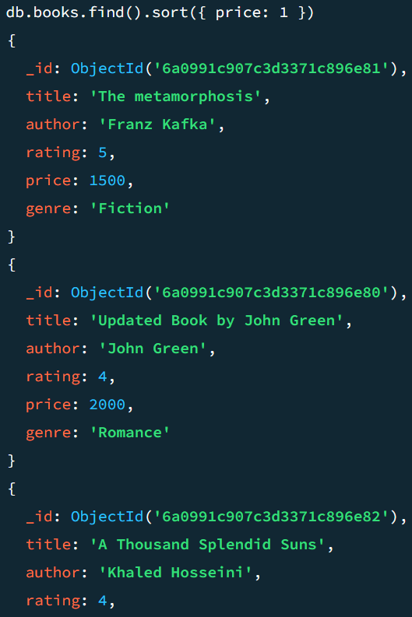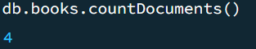
- Delete the book with the name ‘A thousand splendid suns’ from the books collection.
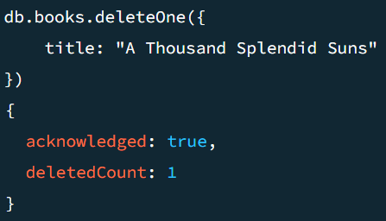
7. Answer the following questions:
- • What have you learned from the lab task?
I learned how to create a database and collections in MongoDB. I also learned how to insert, find, update, sort, count, and delete records.
- • What was the most challenging task and how did you overcome that challenge?
The most challenging part was getting familiar with MongoDB commands and syntax. I overcame this challenge by practicing the commands and trying them multiple times.

